Load balancer using EC2 Instance

**Launch webserver on instance and create load balancer:**

Load balancer is used to divert the traffic on multiple instances so, there are very less chances of server crash. This method is used to prevent hacking attacks like DoS, DDoS. If you have created load balancer and there are two visitors who are going to visit your site then, load balancer will display content of instance 1 to first visitor and content of instance 2 to the another visitor.

1. Create and access any instance using mobaxterm - (here I am using Redhat instance, if you launch other instance then there will be different command to launch webserver.)

[Note: Refer Implementation of IaaS to launch and access the instance.]

1. After launching and accessing the instance using mobaxterm. Login to root user using command:

**#sudo –i** (Work on both redhat and Ubuntu also.)

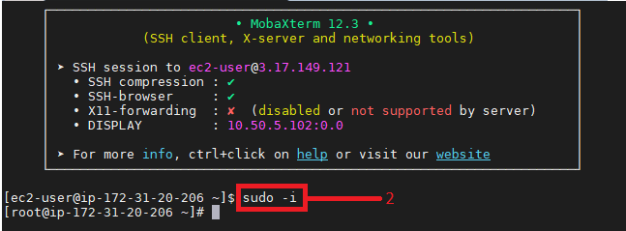

1. Install webserver using command: **#yum install httpd –y**

For Ubuntu: **#apt-get install apache2**



1. Enable and restart the httpd or apache2 service.

**#systemctl enable httpd  
#systemctl restart httpd**(Command will be same for Ubuntu just replace httpd with apache2)



1. Go to default directory of the webserver (same for Ubuntu and redhat) /var/www/html directory. Insert some code into index.html and restart webserver using following commands. (These commands are same for Ubuntu and redhat just change httpd with apache2 in Ubuntu)

**#cd /var/www/html**

**#echo “<h>demo1</h>” > index.html**

**#systemctl restart httpd**



1. Now we need to test that our demo webserver is launched or not, so simply open your browser and copy and paste ipv4 address of your instance which you used to access it using mobaxterm.

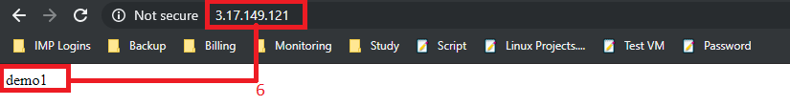

1. Now we are going to create AMI image (snapshot) of this EC2 instance. Which will help us to launch same instance with same changes therefore we will not need to install and configure webserver again on new instance. Follow implementation of IaaS pdf to create AMI Image of current instance. After creating the image again go to services and click on EC2.

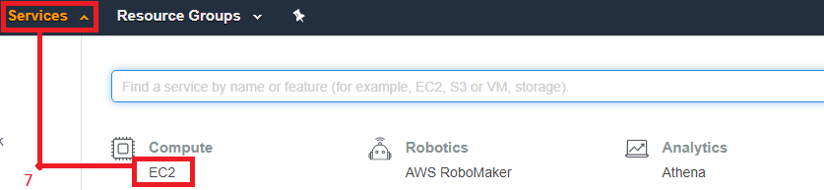

1. **Launch Instance.**

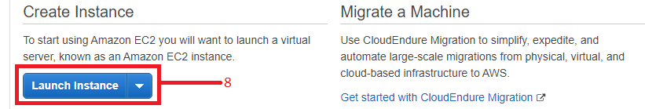

1. Click on My AMIs and Select the instance image of which we have taken the snapshot.

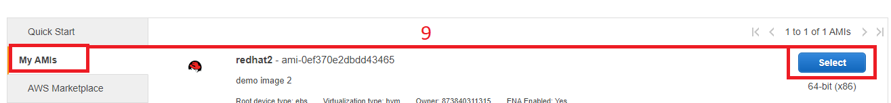

1. Click on **Next: Configure instance Details**.

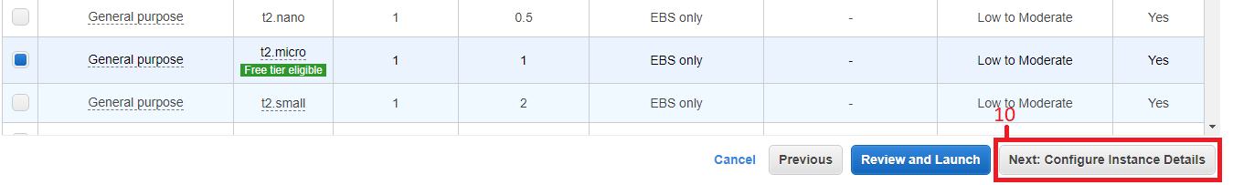

1. Click on **Next: Add Storage**.

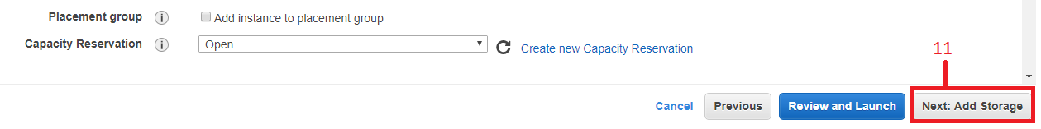

1. Click on **Next: Add Tags.**



1. Click on **Next: Configure Security Group.**



1. Create new security group or **select an existing security group** which you have created while launching first instance. After that click on **Review and Launch** button.

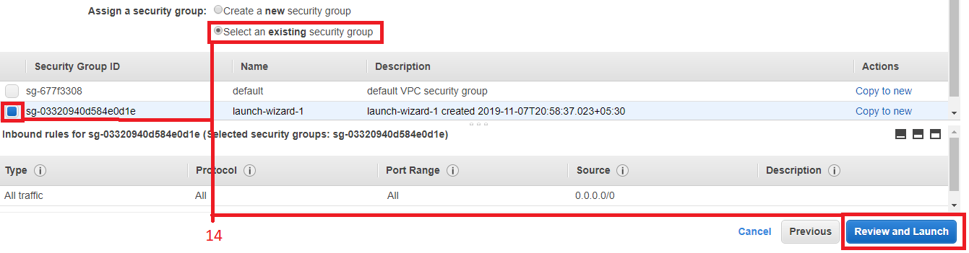

1. Click on Launch button to launch the new instance.



1. If you have already created a key pair while launching the first instance then you will not need to create another one, **choose an existing key pair.** Tick on checkbox before acknowledge and launch the instance. And click on **view instances** (Will appear at bottom right corner when you launch the instance.) to view all instances.

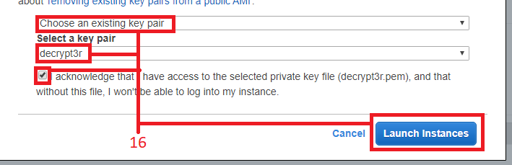

1. Give names to both the Instances (VMs) for your reference (This is an optional step).
2. Untick first instance which we were created before and tick on newly created instance and copy it’s IPv4 address and try to access it using mobaxterm software.

[Note: Refer Implementation of IaaS to access the instance.]

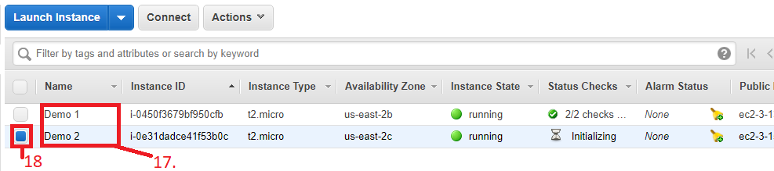

1. We have launched a new instance from snapshot of first instance so here we will not need to install webserver (When you take snapshot of any instance, it automatically creates replica of that instance with same settings and configuration). Simply login to **root** user using **#sudo –i** command.

Then add any line of code which you want to add into index.html page of the webserver (Here I am going to add **demo2** word) by using command **#echo “demo2” > /var/www/html/index.html**

And restart the webserver using **#systemctl restart httpd**

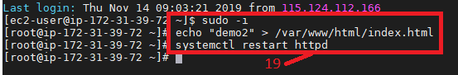

1. Now test whether webserver is configured on new instance or not, Paste IPv4 address of new instance in your web-browser. If it loads means you have successfully launched the webserver.

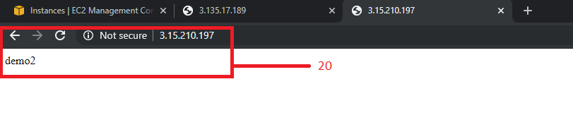

**These were the steps to launch webserver and creating 2 instances with same configuration, now following steps will show actual steps to create load balancer between 2 instances (Virtual Machines)**

1. Go to your web browser’s tab where you have launched the instances. And in bottom left corner scroll down and click on **Load Balancers**.

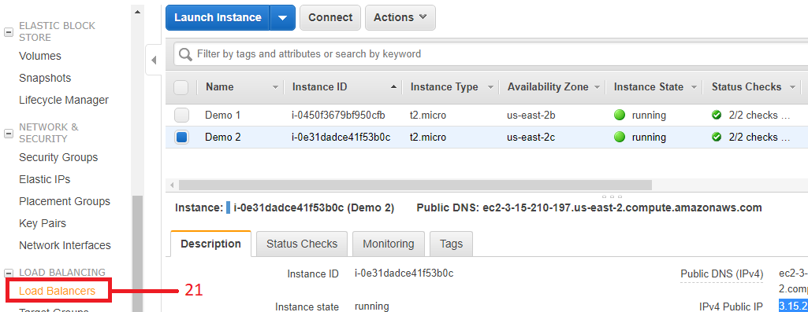

1. Click on **Create Load Balancer** button.



1. Select **Create** button under HTTP, HTTPS option.

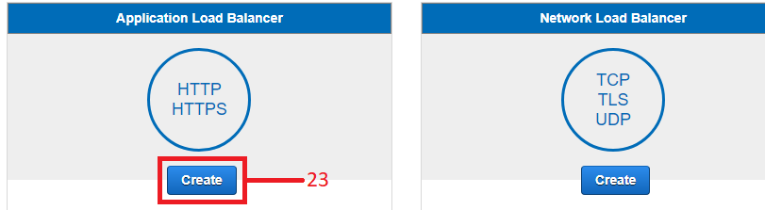

1. In configuration give any name to the load balancer and scroll down.

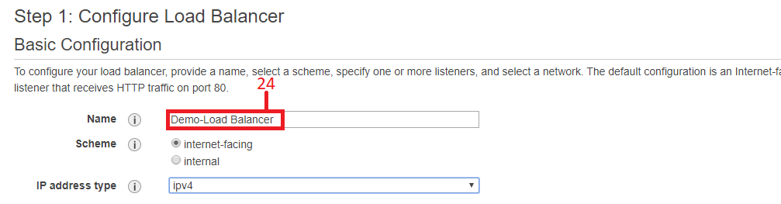

1. Don’t make any changes in other options and select all the available VPCs. And click on **Next: Configure Security Settings**.

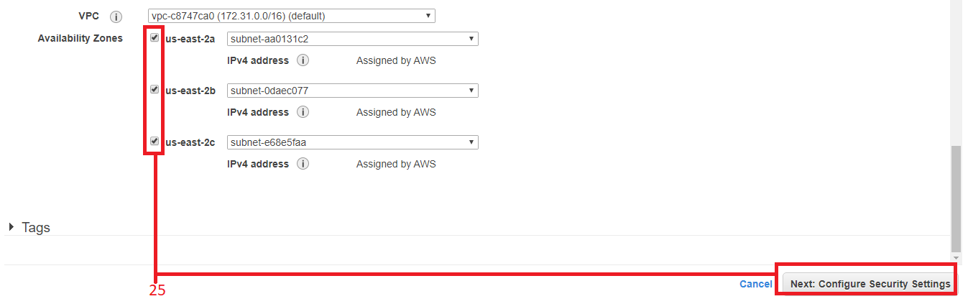

1. Ignore if there is any warning and Click on **Next: Configure Security Groups.**



1. Select an **existing security group** then tick on the security group which we have created while launching the instance and then click on **Next: Configure Routing**.

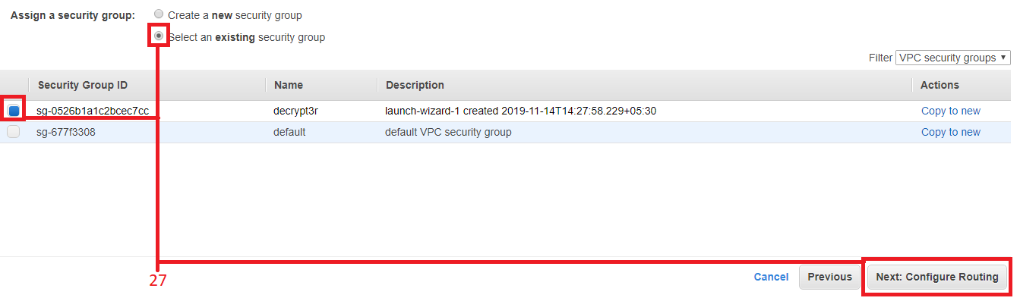

1. Give any name to the target group and click on **Next: Register Targets.** (Note: in **advanced health check settings** you can set time for health check of the instances it is an optional part.)

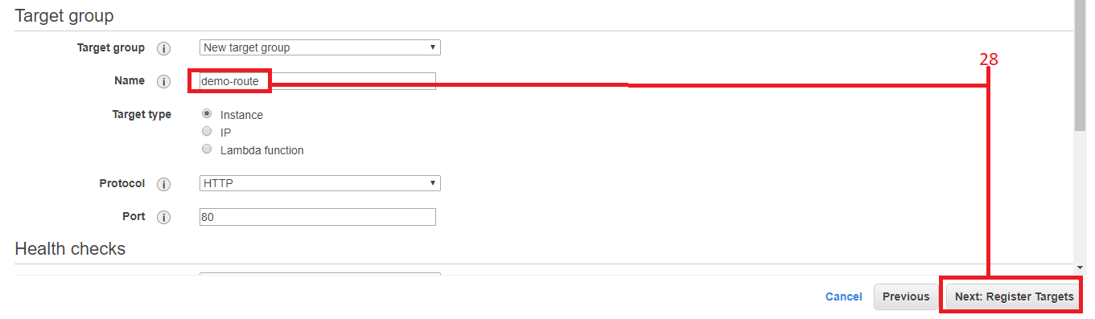

1. Select both the instances to add them into the load balancer.
2. Click on **Add to register.**
3. **Next: Review** and therefore review the changes you have made and Click on **Create** button**.**

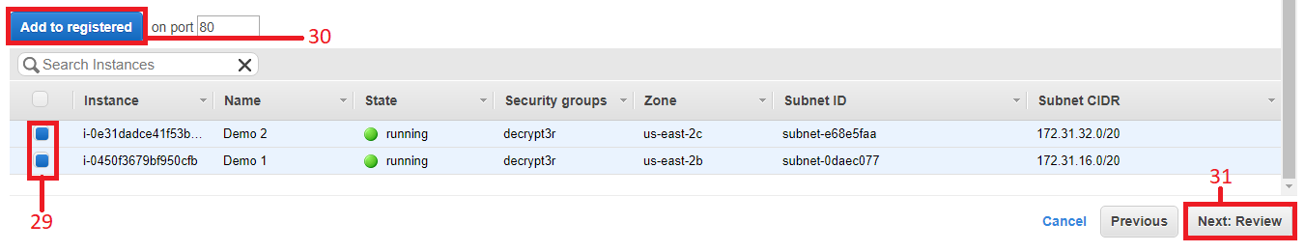

1. You have successfully created a Load balancer between two instances and click on **Close** button.

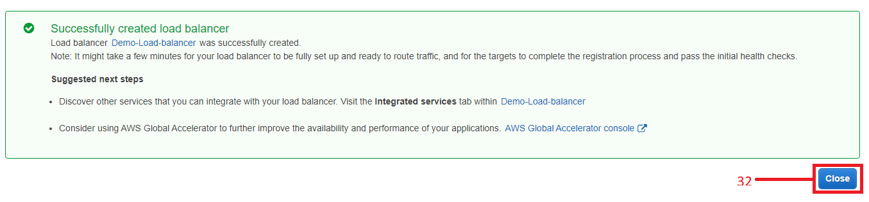

1. Select the load balancer which we have created.
2. And copy its **DNS name.**

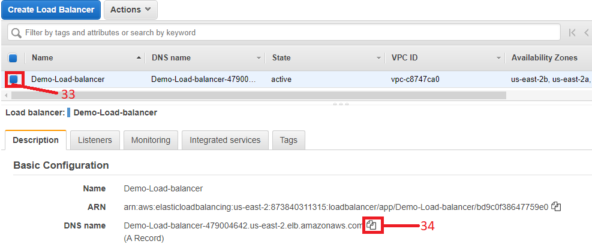

1. Paste that copied DNS name into new tab of the web browser to access that load balancer. (Note: Sometimes it took some time to create load balancer if you get error like page not found then wait for some time and then refresh the page again.)

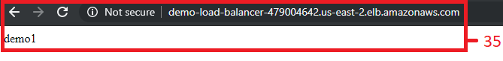

1. Try to refresh the page again and again using F5 or refresh button. Whenever you refreshes the page it automatically send your request to both the instances simultaneously. (Here instance 1 contains demo1 in webserver and instance 2 contains demo2 page when we are refreshing the page it is redirecting us on both the webservers simultaneously.)

